NEA
Eli’s Computer Science NEA

Contents
Analysis 2
Introduction to the problem 2
Identified problems 3
Interview 5
Objectives 6
Ideas: 7
Design 7

Analysis

Project plan:
Analysis (understanding the problem fully)
Design (UI, algorithms, data structures)
Technical solution
Testing (systematic testing plan)
Evaluation (how well it met objectives, possible improvements)

Introduction to the problem

Powerlifting is a strength sport based around three lifts: squat, bench press and deadlift. The combined total across the three lifts gives each competitor a total score. Competitors are categorised by weight into eight weightclasses for both men and women and competitors are judged in each respective weightclass in competition.

Powerlifting is growing in popularity in both in the United Kingdom (currently over 10,000 members) and across the world, growing in size in recent years. For the sport to grow and be recognised it needs to be accessible to new participants. Coaching is highly specialised and expensive, which can discourage people from joining the sport.

Accessible and affordable tools would help new and established powerlifters to set goals, monitor and track progress and plan workouts. This promotes the consistency which is so vital in this sport.

A clear tracker program will help lifters to develop their skills and abilities, reach new targets and engage in a personalised program that avoids injury, prevents overtraining or under-recovery.

There is a significant evidence base for maximising performance in this sport. A program needs to monitor a wide range of variables, including weight lifted, number of reps, length of rest periods, personal bests, progressive overload, and Rate of Perceived Exertion (RPE) of any given lift. A program of this nature allows the lifter to analyse trends and make informed adjustments. A program would also enable a new and developing lifter to progress without financial investment.

Identified problems

The problem is that powerlifters can find coaching expensive and inaccessible. This application will offer a solution by supporting powerlifters to track progress and develop in their sport.

Current problems

Currently, people typically use a mixture of Google Sheets to share and monitor the workout program and WhatsApp to share videos of each lift and communicate about what form changes to make. My goal is to create a platform that can be used to smooth the coaching process in a way that is easy to implement for anyone to use even if they are more digitally averse. I could have a large selection of demonstration videos of each lift in order to help people who do not have a coach to adequately learn how to complete the program without additional support. This will benefit the athletes by making it easier to learn how to lift properly, and easier for beginners who do not have a coach to get free programming. It will also benefit the coaches by having all of their athletes’ programs in the same location, allowing for better organisation when having dozens of clients.

End users of the project

Powerlifters will be the main users of the system. They will use the platform to record their lifts, track their workouts over time, and monitor their progress. The system will provide a clear, structuredway for powerlifters to do all of this within one location. Powerlifters will also benefit from the demonstration videos included within the platform. These will help users learn the correct technique for each lift. Additionally, the project will allow coaches to manage many athletes at once on a single platform.

Current system

Currently, people use google sheets or Microsoft excel to organise their programs. At first, they would receive a spreadsheet file including their program, wherein the program will be laid out. They will then open this file and save it. Then, they will edit the program and fill in the weight and intensity (RPE) of each given set of lifts. This can be useful however for some new users it may seem daunting/confusing to use this. See below how one program may be laid out:

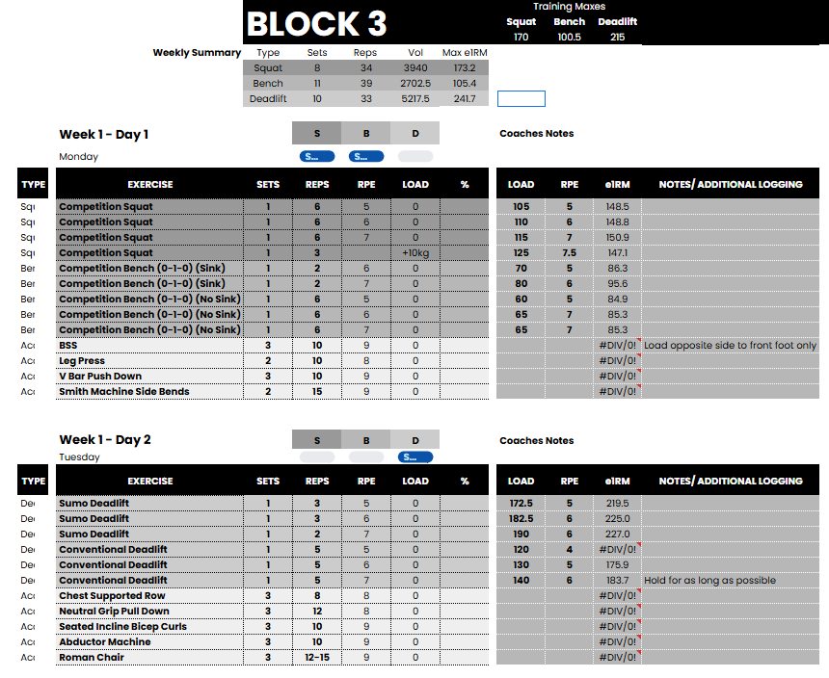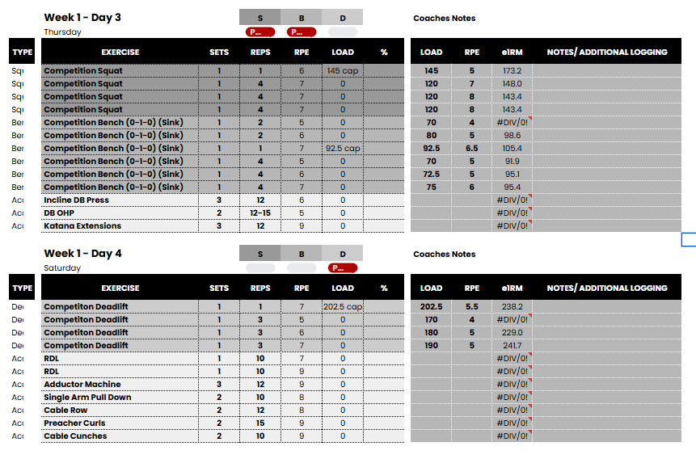
Prescribed set intensity
Estimated 1 rep max
Load used
Prescribed number of sets
Prescribed number of reps
Prescribed intensity
Prescribed lift

Interview

1: How do you currently keep track of your progress?
A: On a google sheets page with a spreadsheet
2: Do you have a written workout program or do you just do whatever you feel like doing on the day?
A: I use a written workout program given to me by my coach
3: How do you keep track of your PBs and would seeing graphs of your pbs over time help with your motivation?
A: Yes they would, I find that sometimes I lose motivation because i keep track of my PBs off the top of my head
4: Have you ever used video examples/demonstrations to help improve your technique?
A: All the time
5: Did you find these helpful?
A: Very helpful. They gave me information in a visual way which allowed me to picture it easily
6: Do you have any specific goals for the future?
A: Nothing specific, but some minor ones along the way
7: On an online platform, which of the topics we have covered would you find to be the most helpful?
A: Video examples because normally its kind of hard to find them but if they were all contained in one platform then it would be easier to find them
8: How often would you use a platform like this?
A: Every time I train which would be 4 times per week
9: Is there anything else you would like to be included that hasn't been mentioned so far?
A: Nutrition tips/advice, and supplement recommendations

Overall, from this interview, I have managed to figure out a lot more ideas about my project and it has helped me think of additional features I could include, alongside the things that I should probably prioritise. For example, I now know that supplement tips and advice would be quite helpful to include, alongside nutrition tips which can allow platform users to properly fuel themselves for their workouts. Also, I know that video examples are something I should put additional effort into in order to make sure that anyone using the platform will adequately be able to carry out each exercise with certainty that they are doing it correctly.
Question | Answer | Take away
1 | On a google sheets page with a spreadsheet | I don’t need to overcomplicate the visual representation of the program to work
2 | I use a written workout program given to me by my coach | I should allow people to upload a program to a database, and someone else to retrieve it
3 | Yes they would, I find that sometimes I lose motivation because i keep track of my PBs off the top of my head | I should add a location in which I can store each of someone’s pb lift numbers
4 | All the time | I should add video examples
5 | Very helpful. They gave me information in a visual way which allowed me to picture it easily | I should record high quality informative videos
6 | Nothing specific, but some minor ones along the way | I will not be including this in my project
7 | Video examples because normally its kind of hard to find them but if they were all contained in one platform then it would be easier to find them | Video example are a very important part of the platform
8 | Every time I train which would be 4 times per week | I will not be including this in my project
9 | Nutrition tips/advice, and supplement recommendations | I need to do research and put what I learn into a page somewhere, maybe a frequently asked nutrition questions page?

Objectives

- New users must register to the system
  - Should be able to create a username and password
  - Username must be
  - Password must be 8 characters long
  - Passwords must be stored in a secure location that cannot be easily accessed
- Validation and verification techniques

- To log in, users must input their username and password
  - Clear, easy to navigate user interface

- A program needs to monitor a wide range of variables

- a large selection of demonstration videos of each lift

- allow users to store workout programs
- allow users to record training information such as weight, repetitions and RPE
- allow users to view demonstration videos for exercises
- allow users to store and view personal best lifts
- allow users to view previously used training programs
- allow coaches to view the programs of their clients
- allow users to log out of the system

Non-Functional requirements

Usability – the system should have a clear and simple graphical user interface. Many new users may not have experience using more complex software, so the site should be easy to navigate.
Security – user information such as passwords must be stored securely in order to prevent unauthorised access to accounts.
Reliability – the system must store user training data reliably so that users will not lose information that is uploaded to the site.
Performance – the ste should respond quickly to inputs from the user so that navigation between pages and uploading of data doesn't have a negative affect of the user’s experience.

Inputs, processes and outputs

Input | Process | Output
Username | Validating login details | Saved programs
Password | Storing user data in database | Personal best lifts
Weight lifted | Retrieving saved programs | Lists of exercises
Number of reps completed | Updating stored workout data | Demo videos
Rate of perceived exertion | Displaying demo videos | User account info

Constraints

Time – the project must be completed withing the timeframe given for the NEA. This means that not all features may necessarily be able to be completed, in order yp ensure that the project is completed on time.
Technical – the system must run on all computers, even if the hardware is outdated. This means that the site must not require unnecessary processing power
Skill -

Design

Data item | Data type | Validation/restrictions
Username | String | -Must be unique on the system  -Must be more than 3 characters
Password | String | -must be at least 8 characters  -must have a capital letter  -must contain a symbol  -must enter twice to verify

Sign in page

This will allow users to either sign in to an existing account or create a new one if they do not have one already.
Calibri (Body)

Sign In/Create Account
Username:
Password:
Forgot password?
Calibri (Body)
Calibri (Body)
Calibri (Body)
#6DADDB
#57C3D9

L

Navigation Page

This is the main page users will see after logging in to the system. It will allow them to use whatever functions of the website that they want to use.
Calibri (Body)
Calibri (Body)


Navigation
Your workout program
Video Examples

#6DADDB

Calibri (Body)
#57C3D9
#6DADDB

Page navigation:
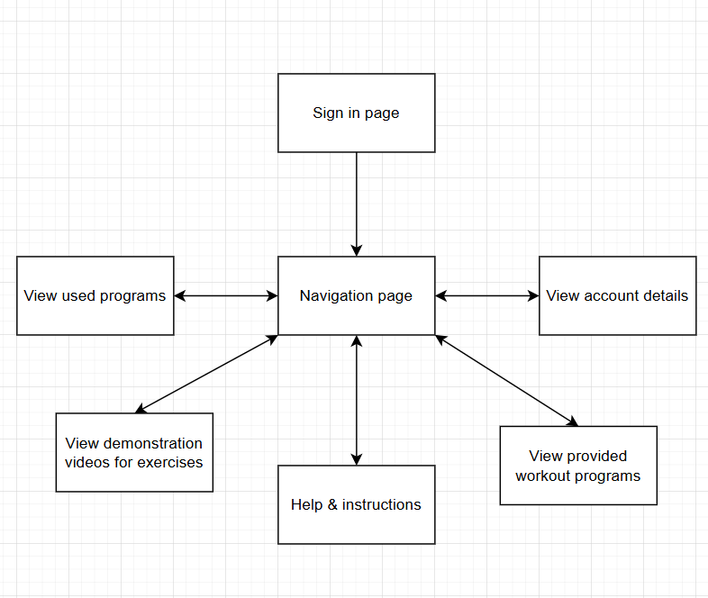

Page | Use
Sign in page | This is where users will either sign in to an existing account or create a new one
Navigation page | This is the central hub where users will be able to access all of the features of the site
View used programs | This is where users can view the programmes that they’ve saved to their account so that they can edit them and fill them in with the completed exercises
View demonstration videos for exercises | I will create demonstration videos for many exercises, all of which can be accessed here
View provided programs | This is where users will be able to browse the programs that are provided be the site
View account details | This is where users will be able to view account details, log out, etc.
Help & Instructions | This will explain how to use the site and will explain any terminology that a beginner may struggle to understand

